

**Belagavi**

**Campus**

**Dr.M.Sheshgiri College of Engineering & Technology**

A Report on the Course Project of

**Engineering Exploration**

**(22ECRP101)**

**CONTACTLESS MEDICINE DISPENSER**

By

|  |  |  |
| --- | --- | --- |
| Akhilesh Joshi | 302 | 02fe22bcs13 |
| Nikita Mallur | 317 | 02fe22bec041 |
| Shivanagouda Patil | 333 | 02fe22bcs121 |
| Sangeeta Toli | 349 | 02fe22bcs104 |
|  |  |  |

**Under the guidance of**

**Proff Sushant Jadhav**

**Assistance professor , E&C dept , KLE TECH BGM CAMPUS**

Centre for Engineering Education Research

KLE Technological University, Hubballi

Karnataka .India

Academic Year 2022-2023, Even Semester

#### CERTIFICATE

This is to certify that the course project entitled “CONTACTLESS MEDICINE DISPENSER” is carried out by the students Akhilesh Joshi (302), Nikita Mallur (317), Shivanagouda Patil (333), Sangeeta Toli (349) as part of Engineering Exploration Course (22ECRP101), during 2nd Semester of B.E program for the academic year 2022-23. The project report fulfils the requirements prescribed by KLE Technological University , Dr.M.S.Sheshgiri College of Engineering & Technology, Belagavi ,Karnataka ,India.

|  |  |
| --- | --- |
| __________________  Guide  Proff Sushant Jadhav    ________________  Examiner 1: | __________________  Class Teacher  Proff Anita Shirol  __________________  Examiner 2: |

### DECLARATION

We hereby declare that the project work entitled “CONTACTLESS MEDICINE DISPENSER” submitted as a part of Engineering Exploration Course during 2nd semester of academic year 2022-2023, is a record of an original work done by us under the guidance of Proff Sushant Jadhav. The project work and part of this report is not plagiarized to the best of our knowledge.

Date: 27/07/2023

|  |  |  |  |  |
| --- | --- | --- | --- | --- |
| Sign | Sign | Sign | Sign |  |
| Akhilesh Joshi | Nikita Mallur | Shivanagouda Patil | Sangeeta Toli |  |
| 302 | 317 | 333 | 349 |  |

**ACKNOWLEDGEMENT**

I would like to express my sincere thanks to **Prof Sushant Jadhav**, for his valuable guidance and support in completing my Course project.

I would like to express my gratitude toward **all my division staffs** as well as the **Prof. S B Kulkarni** for providing me a great opportunity to complete a  project on “CONTACTLESS MEDICINE DISPENSER”. Without their support and suggestions, this project would not have been completed.

I would also like to express my gratitude towards our principal **Dr. S F PATIL** for giving me this great opportunity to do a project on “CONTACTLESS MEDICINE DISPENSER” .

**Index**

|  |  |
| --- | --- |
| List of Figures | i |
| List of Tables | ii |
| Abstract | iii |
| 1. Problem Definition | **1** |
| * 1. Need Statement | **4** |
| * 1. Literature Survey | **4** |
| * 1. Questions asked to client / users for arriving at Objectives, Functions and Constraints | **5** |
| * 1. Objectives | **6** |
| * 1. Constraints | **7** |
| * 1. Functions | **8** |
| 1. Conceptual Design |  |
| * 1. Establishing Functions | **9** |
| * 1. Functions Tree | **10** |
| * 1. Morphological Chart | **10** |
| * 1. Generated Concepts | **11** |
| 1. Conceptual Evaluation and Product Architecture |
| * 1. Pugh Chart | **12** |
| * 1. Justification for the Scores | **13** |
| * 1. Selected Design | **14** |
| * 1. Product Architecture      1. Function Clustering | **15** |
| * + 1. Interaction between subsystems | **16** |
| 1. Implementation    1. Sprint 1 Implementation       1. 3D model of the sprint 1 | **17**  **18** |
| * + 1. Bill of Materials (BOM) of the sprint 1 | **18** |
| * + 1. Circuit diagram of the sprint 1 | **19** |
| * + 1. Flow chart of the sprint 1 | **19** |
| * + 1. Physical implementation image of the sprint 1 | **20** |
| * 1. Sprint 2 Implementation      1. 3D model of the sprint 2 | **20** |
| * + 1. Bill of Materials (BOM) of the sprint 2 | **21** |
| * + 1. Circuit diagram of the sprint 2 | **22** |
| * + 1. Flow chart of the sprint 2 | **22** |
| * + 1. Physical implementation image of the sprint 2 | **23** |
| * 1. Sprint 1 Implementation      1. 3D model of the sprint 3 | **23**  **24** |
| * + 1. Bill of Materials (BOM) of the sprint 3 | **24** |
| * + 1. Circuit diagram of the sprint 3 | **25** |
| * + 1. Flow chart of the sprint 3 | **25** |
| * + 1. Physical implementation image of the sprint 3 | 26 |
|  |  |
| 1. Statement of Expenditure | **26** |
| 1. Limitations of Present work and Future Scope | **27** |
| 1. References | **28** |

**List of Table**

|  |  |  |
| --- | --- | --- |
| **Fig No** | **Name of the Table** | **Page No** |
| **1** | **Objectives , functions and constraints** | **1** |
| **22** | **Objectives** | **2** |
| **3** | **Functions** | **4** |
| **4** | **Establishing Functions** | **5** |
| **5** | **Pugh chart** | **9** |
| **6** | **Justification of scores** | **10** |
| **7** | **Interaction between subsystems** | **12** |

i

**List of Figure**

|  |  |  |
| --- | --- | --- |
| **Table No** | **Name of the Figure** | **Page No** |
| **1** | **Function tree** | **6** |
| **2** | **Morphological chart** | **7** |
| **3** | **Generated concepts** | **8** |
| **4** | **Selected Concepts** | **11** |
| **5** | **Function clustering** | **12** |
| **6** | **3D model** | **19** |
| **7** | **Circuit Diagram** | **21** |
| **8** | **Bill of materials** | **20** |
| **9** | **Physical implementation** | **21** |

**Abstract**

The "Contactless Dispenser" is an innovative and vital project developed by our team, designed to address the pressing need for maintaining hygiene and preventing the spread of diseases, especially in times of pandemics and healthcare settings. Utilizing Arduino technology and incorporating IR sensor detection as the input mechanism, our dispenser offers a touchless and hygienic solution for various liquid dispensing applications. By eliminating physical contact, this device minimizes the risk of cross-contamination, making it an ideal choice for hospitals, public spaces, and other critical areas where hygiene is of utmost importance.

The Contactless Dispenser features a versatile design, employing a servo motor actuator for precise pill dispensing and a rack and pinion mechanism for efficient bandage roll distribution. The use of acrylic sheets as sides ensures sturdiness and transparency, allowing users to monitor the contents easily. Additionally, a foam sheet serves as a stable and hygienic base for the dispenser, further enhancing its reliability. The combination of these materials and mechanisms results in a robust and user-friendly product that promotes safer interactions and hygiene practices. The Contactless Dispenser proves to be an invaluable asset in safeguarding public health and can be seamlessly integrated into various environments, significantly contributing to disease prevention during challenging times.

iii

**1. Problem Definition**

**1.1. Need Statement:**

**Design a Semiautomatic medical first aid dispensing kit which is able to dispense accurately syrups and pills both. The machine should be easily portable and user friendly. The machine should not exceed cubic feet. It should be able to notify if stock gets over and also after every dispense. The budget to build the machine should be maximum of 3000 INR. The machine should be able to refill the stocks automatically after it gets over. Should be able to get used at hospitals, schools, home and sport places.**

**1.3. Questions asked to client / users for arriving at Objectives, Functions and Constraints**

|  |  |  |  |  |  |
| --- | --- | --- | --- | --- | --- |
| **Sl. No.** | **Questions** | **Answers** | **O** | **C** | **F** |
| **1** | Whether you want automatic or semiautomatic or manual? | Semi-automatic | **O** |  |  |
| **2** | What is your budget? | Maximum 3000 INR |  | **C** |  |
| **3** | What do you want to dispense? syrups or pills or both? | Both |  |  | **F** |
| **4** | Whether you want the kit to be fixed at place or portable? | Portable | **O** |  |  |
| **5** | Do you want aerosols also to be dispensed? | Yes, if possible |  |  | **F** |
| **6** | What size do you want it to be? | Should be approximately of 1 x 1 x 1 ft |  | **C** |  |
| **7** | Do you want to get notified after dispensing? | Yes, Also notify if stock gets over |  |  | **F** |
| **8**  **9** | Do you want the refilling of stock automatic?    In how much time period do you need it? | Approximately 2 months.  If possible, in my budget |  | **C** |  |
| **10** | In what places do you want to use the machine? | Hospitals, homes, schools, industries, sports. | **O** |  |  |

**1.4. Objectives**

|  |  |
| --- | --- |
| **Sl. No** | **Objectives** |
| **01** | |  | | --- | | Machine should be Semi-automatic. | |  | |
| **02** | Machine can be used at different locations |
| **03** | |  | | --- | | Machine should be portable. | |  | |

**Problem definition 1.1**

Design a semiautomatic first aid medicine dispensing kit, which is portable and easy to use

**1.5. Constraints**

|  |  |
| --- | --- |
| **Sl. No** | **Constraints** |
| **01** | |  |  | | --- | --- | | |  | | --- | | Machine should be ready within 2 months | | |
| **02** | |  | | --- | | Dimensions of machine should be approximately 1 x 1 x 1 ft | |
| **03** | Cost of the machine should be within Rs-3000 |

**Problem definition 1.2**

Design a semiautomatic first aid medicine dispensing kit. The machine should be of size 1x1x1ft. The machine should be ready within 2 months and also should cost within 3000/-.

**1.6. Functions**

|  |  |
| --- | --- |
| **Sl. No** | **Functions** |
| **01** | |  | | --- | | Machine should dispense different types of pills | |  | |
| **02** | |  | | --- | | Aerosols should also be dispensed if possible | |  | |
| **03** | |  | | --- | | Should notify after each dispense | |  | |
| **04** | The refilling of the stock should be automatic |

**Problem definition 1.3:-**

Design a Semiautomatic medical first aid dispensing kit which is able to dispense accurately syrups and pills both. The machine should be easily portable and user friendly. The machine should not exceed cubic feet. It should be able to notify if stock gets over and also after every dispense. The budget to build the machine should be maximum of 3000 INR. The machine should be able to refill the stocks automatically after it gets over. Should be able to get used at hospitals, schools, home and sport places.

**2. Conceptual Design**

**2.1. Establishing Functions**

|  |  |  |
| --- | --- | --- |
| **Sl. No** | **Functions from user perspective** | **Functions from the designer perspective** |
| **01** | Machines which dispenses various pills | |  | | --- | | Bandages should also be dispensed | |  | |
| **02** | Semiautomatic refilling | manual refill |

**2.2. Functions Tree**.

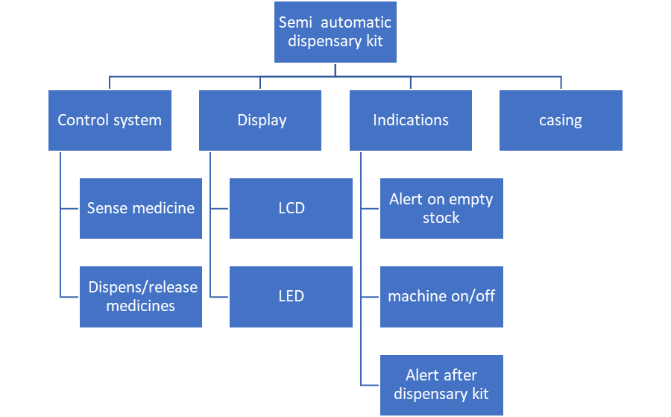

**2.3. Morphological Chart**.

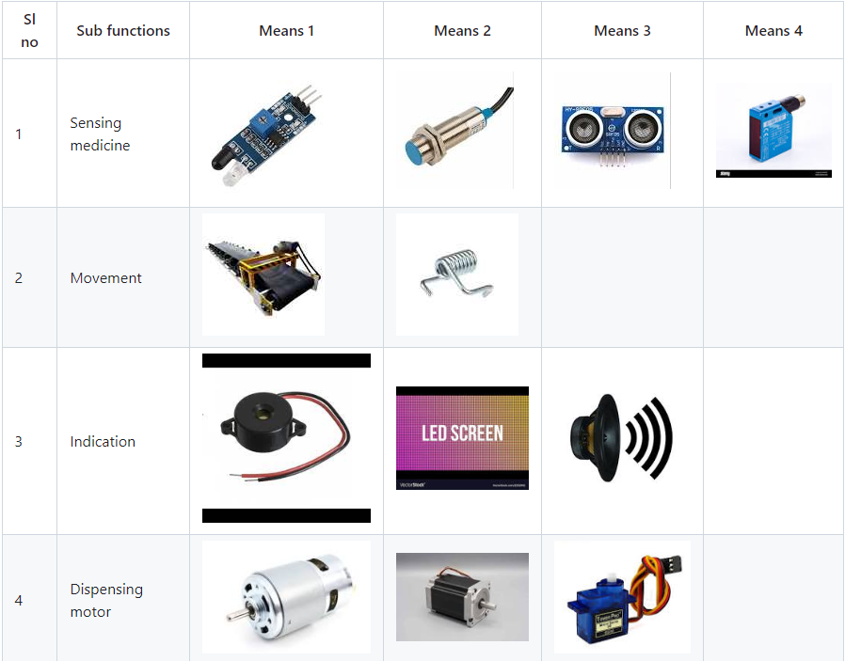

**2.4. Generated Concepts**

|  |  |
| --- | --- |
| **Concept 1**    By:-Akhilesh Joshi | **Concept 3**    By:-Shivanagouda Patil |
| **Concept 2**    By:-Nikita Mallur | Concept 4    By:-Sangeeta Toli |

**3. Conceptual Evaluation and Product Architecture**

**3.1. Pugh Chart**

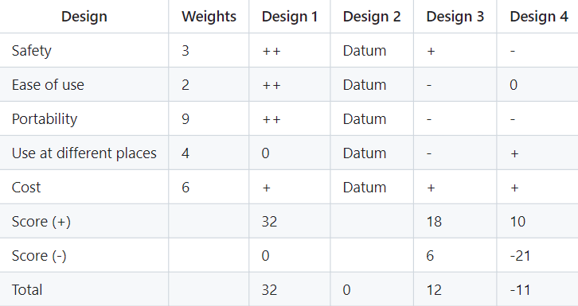

**3.2. Justification for the Scores.**

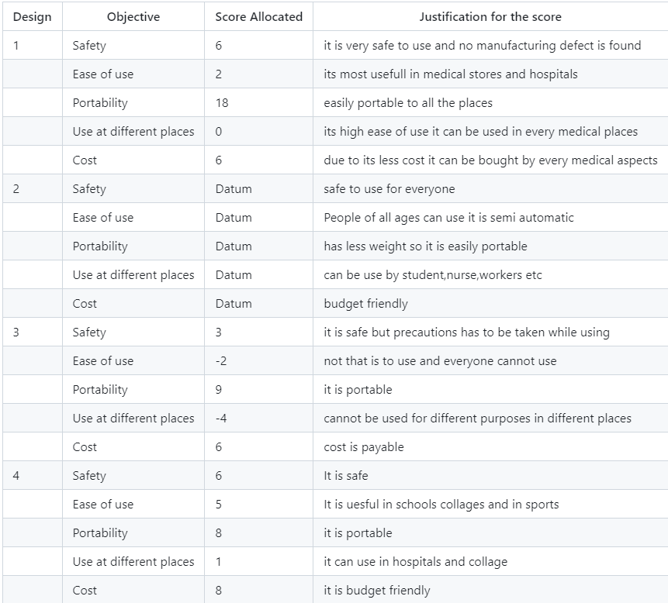

**3.3 Selected Design**

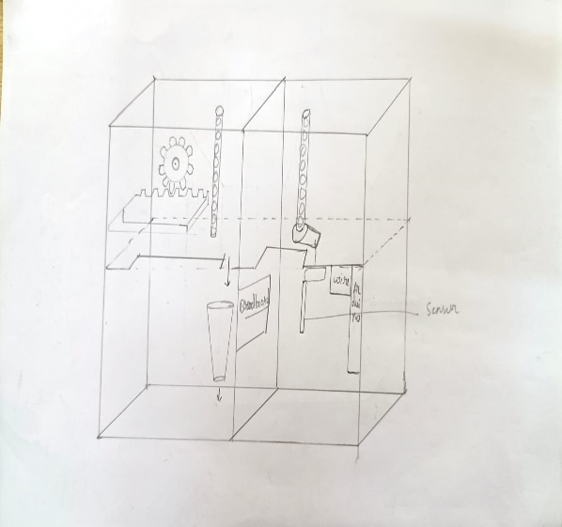

**3.4 Product Architecture**

**3.4.1 Function Clustering**

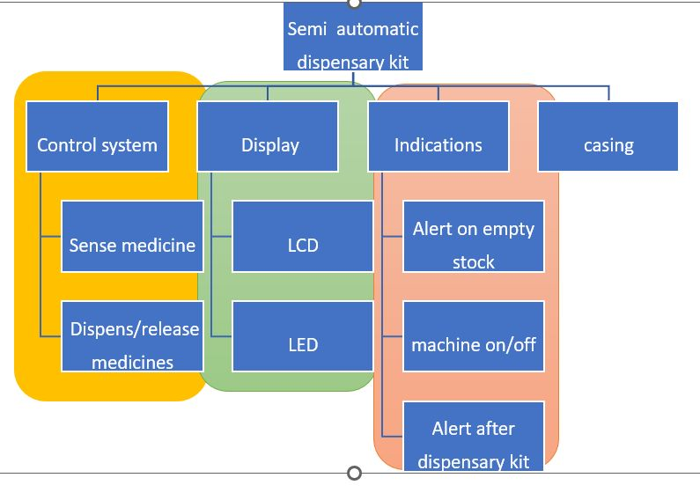

**3.4.2 Interaction between subsystems**

|  |  |  |  |  |
| --- | --- | --- | --- | --- |
|  |  | display system | indication system |  |
| control system | Material Interaction | ✓ | X |  |
| Data Interaction | X | ✓ |  |
| Spatial Interaction | X | X |  |
| components of control system can materially interact with display system  components of control system interact with indication system on databases  components of control system never interact spatially with any substsystems | | | | |

|  |  |  |  |  |
| --- | --- | --- | --- | --- |
|  |  | control system | indication system |  |
| display system | Material Interaction | ✓ | X |  |
| Data Interaction | X | ✓ |  |
| Spatial Interaction | X | X |  |
| components of display system can materially interact with control system  components of display system interact with indication system on databases  components display system never interact spatially with any substsystems | | | | |

|  |  |  |  |  |
| --- | --- | --- | --- | --- |
|  |  | control system | display system |  |
| indication system | Material Interaction | ✓ | X |  |
| Data Interaction | X | ✓ |  |
| Spatial Interaction | X | X |  |
| components of indication system can materially interact with control system  components of indication system interact with display system on databases  components of indication system never interact spatially with any substsystems | | | | |

**4.** **Implementation**

**4.1.** **Sprint 1 Implementation**

**4.1.1. 3D model of the sprint 1 subsystem**

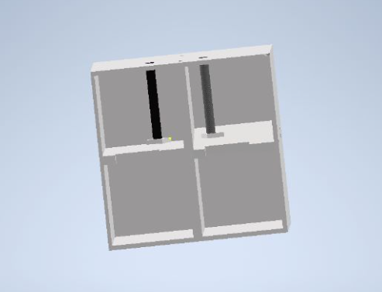

**4.1.2. Bill of Materials (BOM) of the sprint 1**

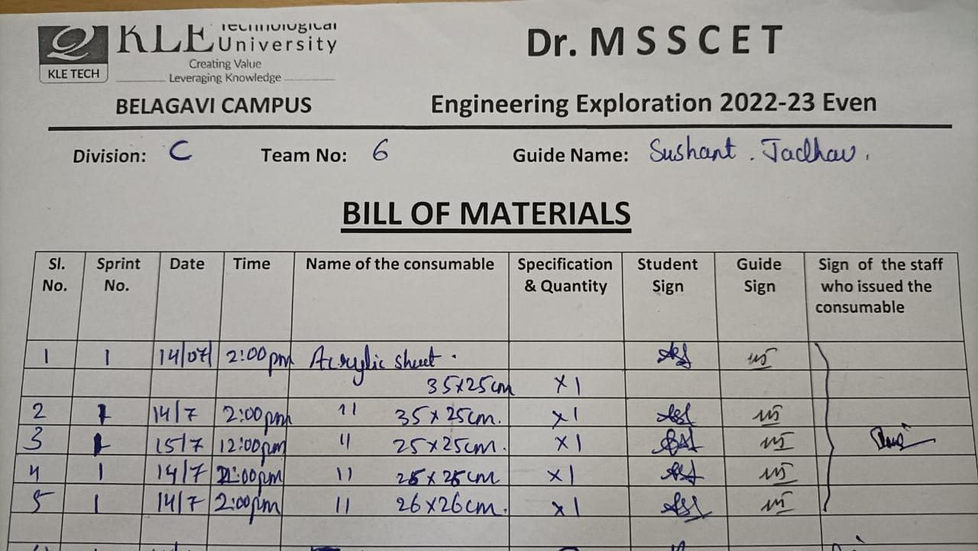

**4.1.3. Circuit diagram of the sprint 1**

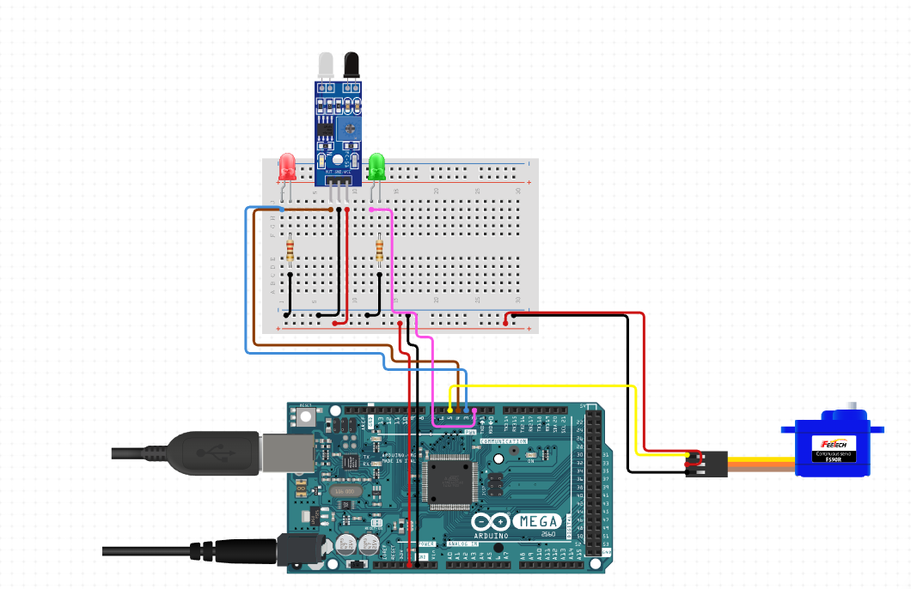.

**4.1.5. Physical implementation image of the sprint 1**

**(laser cutting of sheets for product )**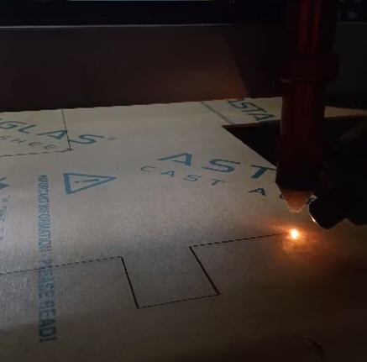

**4.2.** **Sprint 2 Implementation**

**4.2.1. 3D model of the sprint 2**

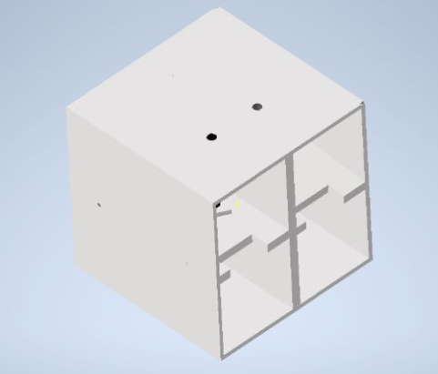

**4.2.2. Bill of Materials (BOM) of the sprint 2**

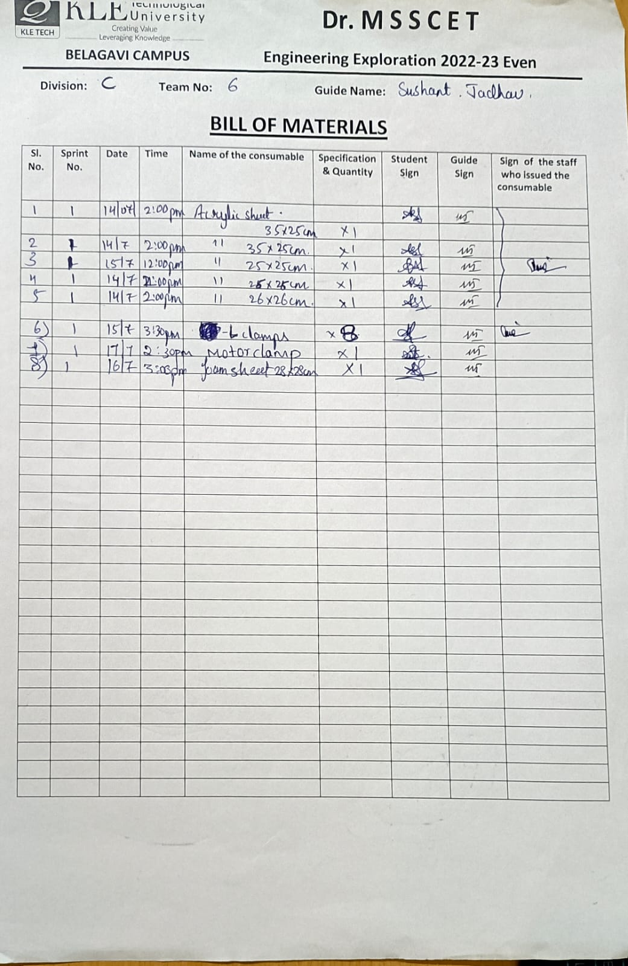

**4.2.3. Circuit diagram of the sprint 2**

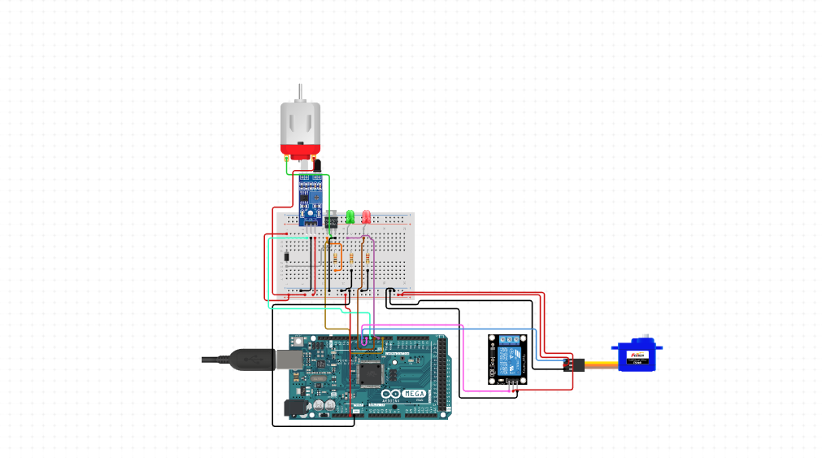

**4.2.5. Physical implementation image of the sprint 2**

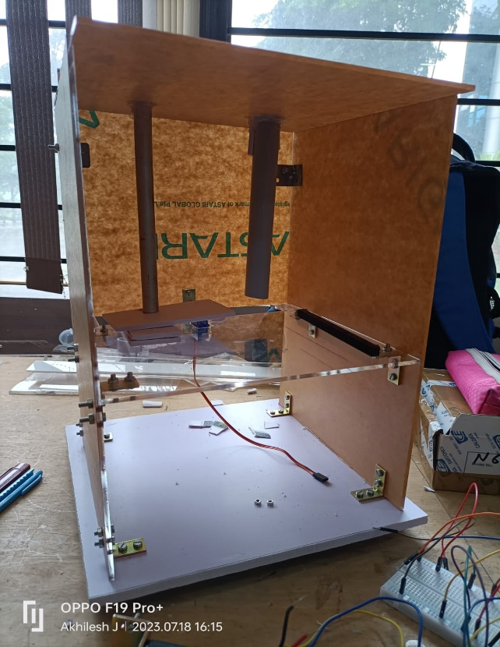

**4.3.** **Sprint 3 Implementation**

**4.3.1. 3D model of the sprint 3 subsystem**

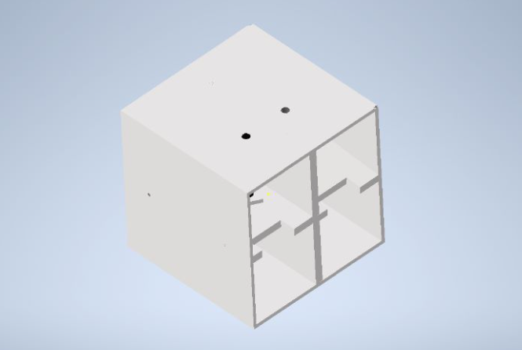

**4.3.2. Bill of Materials (BOM) of the sprint 3**



**4.3.3. Circuit diagram of the sprint 3**

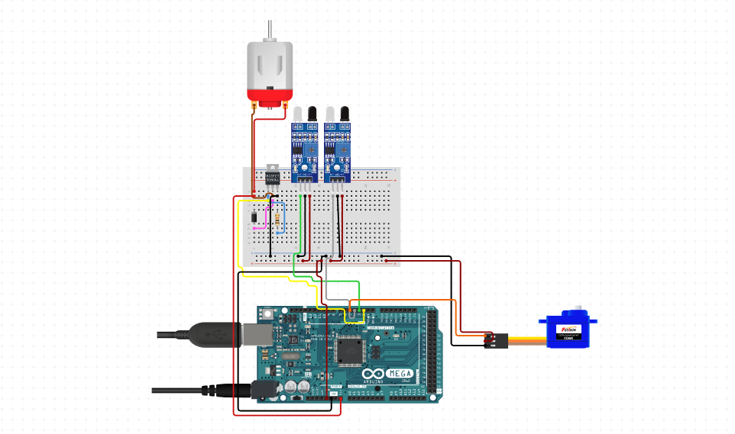

**4.3.5. Physical implementation image of the sprint 3**

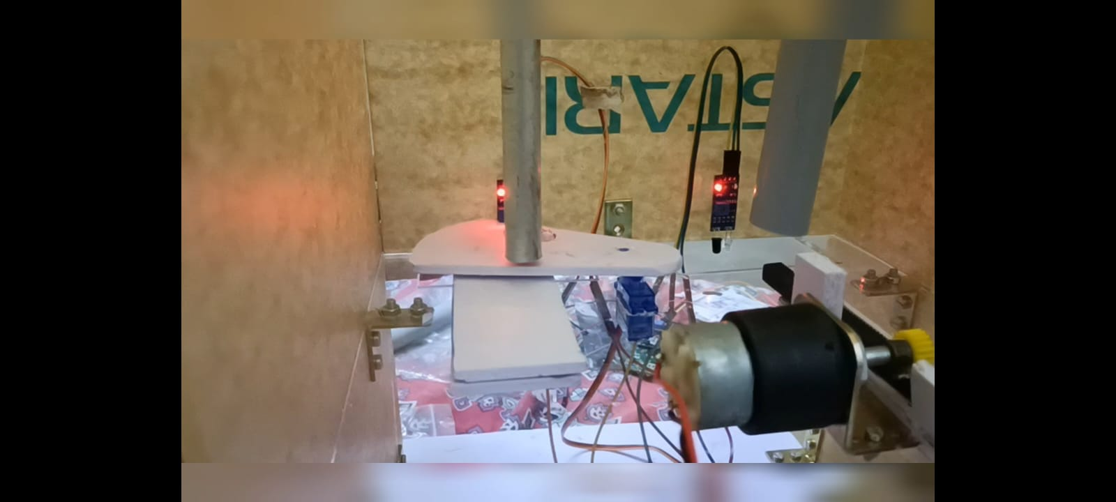

**5**. **Statement of Expenditure**

|  |  |  |  |
| --- | --- | --- | --- |
| Sl. No | Item with description | Quantity | Price in Rs. |
| 1 | Arduino mega 2560 board | 1 | 1400 |
| 2 | Arduino Cable | 1 | 40 |
| 3 | Jumper wire | 3 SETS | 150 |
| 4 | Adapter 12v,1 A | 1 | 150 |
| 5 | Breadboard | 1 | 60 |
| 6 | IR SERSONS | 2 | 80 |
| 7 | Servo motor SG 90 | 1 | 120 |
| 8 | DC motor 30 rpm | 1 | 200 |
| 9 | 2 channel relay | 1 | 100 |
| 10 | RACK | 1 | 60 |
| 11 | PINION | 1 | 45 |
| 12 | SINGLE STRAND WIRE | 1 SET | 40 |
| 13 | ADAPTER JACK | 1 | 20 |
| 14 | DISPENSING MATERIALS | FEW | 14 |
| Total | | | 2479 |

**6. Limitations of Present work and Future Scope**

**Drawbacks:**

1. Limited Dispensing Options: While the Contactless Dispenser excels in touchless liquid dispensing and pill distribution, it currently lacks versatility in dispensing other essential items. Expanding its capabilities to cater to a broader range of medical supplies or personal care products would enhance its practicality and usability.

2. Maintenance and Cleaning: The acrylic sheet sides and foam sheet base, while providing stability and hygiene, might present challenges in terms of cleaning and maintenance. Design improvements should focus on easy disassembly and cleaning procedures to ensure the dispenser's long-term effectiveness and prevent contamination.

3. Dispensing Accuracy: Although the servo motor actuator offers precise pill dispensing, there could be room for further refinement to achieve even greater accuracy and consistency in dispensing volumes. Ensuring an exact dosage is critical in medical settings, and any deviations could impact patient safety.

**Future Scope:**

1. Multi-Product Dispensing: With ample funding, the future scope of the Contactless Dispenser involves expanding its dispensing capabilities to include various medical supplies such as syringes, gauze, gloves, and other essential items required in healthcare facilities. This development would position the dispenser as a comprehensive solution for hospitals and clinics, streamlining their supply chain and enhancing overall efficiency.

2. Smart Connectivity: Integrating the dispenser with IoT (Internet of Things) technology could enable remote monitoring and management of stock levels. A smart system that sends alerts or automatically places orders when supplies run low would ensure a continuous and timely supply of medical items, reducing downtime and potential shortages.

3. Advanced Sensors: Upgrading the IR sensor to include more sophisticated sensing technology, such as proximity sensors or motion detectors, would enhance the user experience and make the dispensing process even more seamless and efficient.

4. Touchless Sanitization: In light of ongoing health concerns, incorporating an integrated touchless hand sanitizer dispenser as part of the system could further contribute to hygiene and disease prevention in public spaces.

5. User Interface Enhancements: Investing in a user-friendly touchscreen interface would make the dispenser more accessible and intuitive for both healthcare professionals and the general public, facilitating a wider adoption of the technology.

6. Modular Design: Implementing a modular design approach would enable easy customization and reconfiguration of the dispenser to accommodate different dispensing needs. This would enhance adaptability and scalability, making it suitable for various environments and applications beyond healthcare settings.

With ample funding and continuous research and development, the Contactless Dispenser has the potential to evolve into a comprehensive and indispensable solution for ensuring hygiene, efficiency, and safety in various domains, positively impacting public health and disease prevention.

**References:**

**Example 1 - Web Page:**

[1] Knaresboro, T. (August 31, 2010). How to Make the Perfect French Fry. Retrieved from <http://www.popularmechanics.com/science/how-to-make-the-perfect-french-fry>.

[2] Author of web page (if available). (Date of publication). Title of web page.Retrieved from URL (web address).

[3] 2016 dictonary.com, http://www.dictionary.com/browse/bibliography

Please note that the below mentioned citations are wrong and should not be included in bibliography, since they are search engines. The references should include the web address of the page from which you have retrieved the information.

[4] www.google.com (This is wrong way of citation)

[5] www.wikipedia.com (This is wrong way of citation)

**Example 2 - Conference Proceedings**

[6] Hahn, H. A. &deVries, J. A. (1991). Identification of human errors of commission using Sneak Analysis.*Proceedings of the Human Factors Society 35th Annual Meeting*.San Francisco, 2-6 September, 1080-1084.

[7] Author Name, Year of the publication, Title of the Project, Title of the conference, Place of conference, Date of conference, Page numbers as according to conference proceedings.

**Example 3 - Book:**

[8] Embrey, D. E., Kontogiannis, T., Green, M. (1994). *Preventing Human Error in Process Safety. Centre for Chemical Process Safety CCP.* New York, NY: American Institute of Chemical Engineers.

[9]Author Name, Year of Publication, Title of the book, Edition, Publisher.